1. Make sure the Rebin Station is offline
   1. Enter this website to an internet browser <https://atzptl.devices.a2z.com> .
   2. Click on the Host Status Tab and search ORD5 under Warehouse ID.
   3. On the webpage one will see many different stations. Look for the station that maybe Offline under the Ping Status.

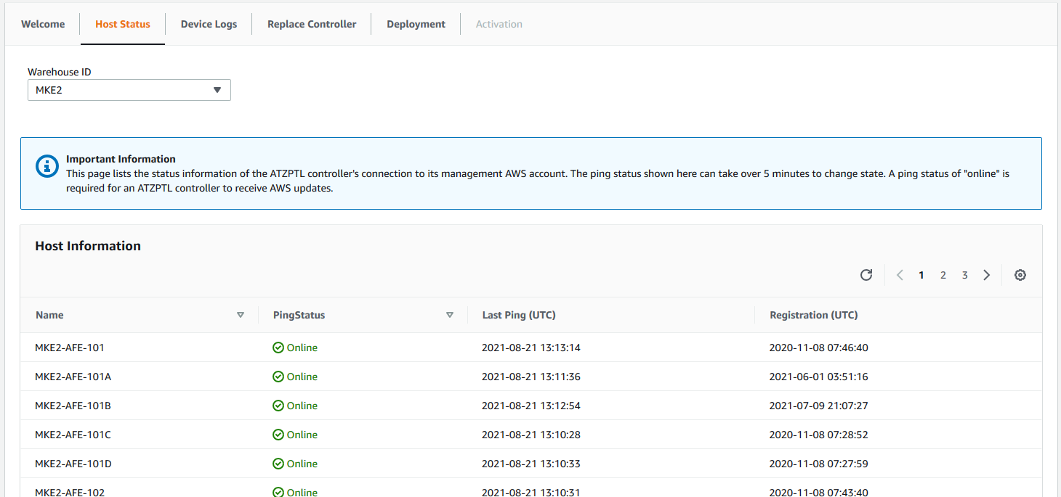

* 1. If the station is Offline then proceed with step 2. If the station is Online the SD card is working.

1. Download Rebin Station File
   1. On the same website click on the Replace Controller tab.
   2. Enter in the Warehouse ID and the Station ID.
   3. Then Click submit.
   4. Once submitted an image of the station will be created.
   5. This will take about 7 minutes and is valid for 24 hours.
   6. Once the image is created download image.

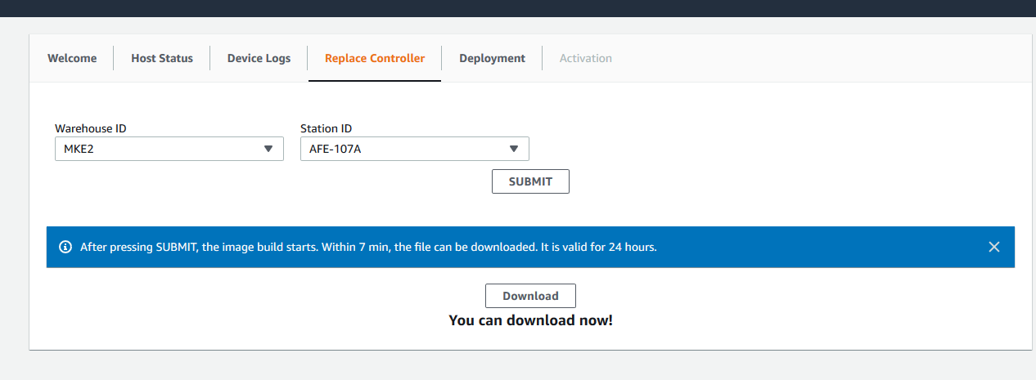

* 1. The image will be in a zip file and will need to be unzipped. Make sure you keep track of the location of the file, which will be a Disk Image File.

1. Download balena-etcher
   1. Enter <https://www.balena.io/etcher/> into your internet browser.
   2. Download the program for windows onto the computer that is being used for this flash process.

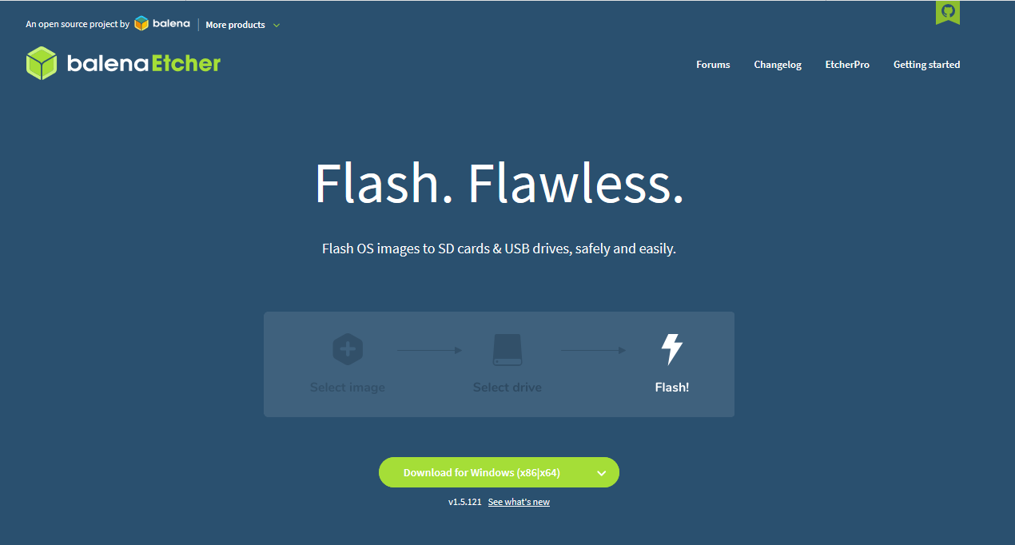

* 1. Once downloaded processed to step 4

1. Flash SD card
   1. Once balena-etcher has been downloaded open the program as administrator.

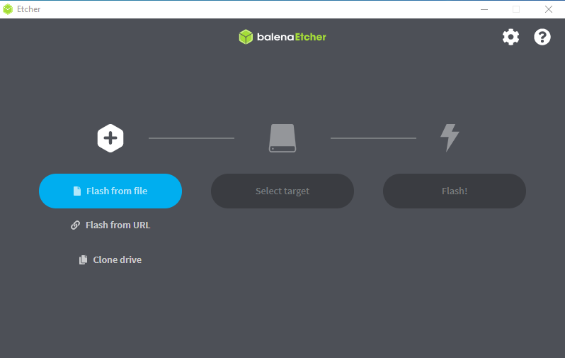

* 1. One will see a window above.
  2. Connect a SD Card docking station to the computer that is being used for this process and insert the SD card into the docking station.
  3. Select the unzipped Rebin station file that will be flashed.
  4. Then select the SD card as the target.
  5. Then click flash. The flashing process will take about 10 minutes.
  6. Once the SD card has been flashed one is able to insert the card into the Picon and turn the Rebin station on. The station will take 10 minutes to load.